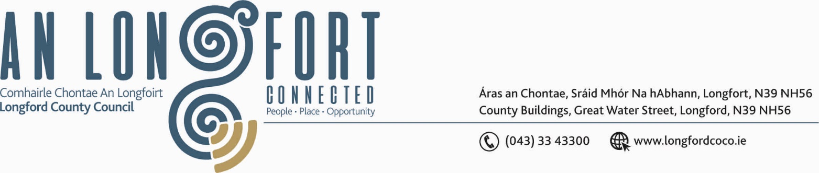

5u Aibrean 2018.

Chuig: Gach Ball don Chomhairle.

A Chomhairleoir,

Iarrtar ort bheith i láthair ag Cruinniú Míosuil Chomhairle Chontae Longfoirt a tionólfar i Seomra na Comhairle, Aras an Chontae, Longfoirt ar an Chéadaoin, 11u Aibrean 2018 ag 3.30 p.m chun gnó a dhéanamh d’réir an Chláir thíos.

You are requested to attend the Monthly Meeting of Longford County Council to be held in the Council Chamber, Aras an Chontae, Great Water Street, Longford, on Wednesday, 11th April 2018 at 3.30 p.m. to transact business, as set out on the Agenda.

Mise le meas,
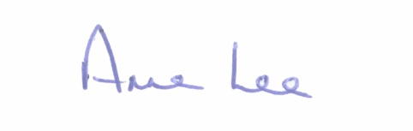

_______________
Anne Lee,
Meetings Administrator.

C L A R

3.30 p.m. - Attendance of Barry Kenny from Iarnrod Eireann.

Prayer before Meeting.

- Confirmation of Minutes of the Monthly Meeting of Longford County Council held on the
14th March 2018 - copy enclosed.

2. Matters arising from Minutes.

3. (a) Consideration of the filling of casual vacancy in the membership of Longford County Council following the resignation of Councillor John Duffy in accordance with Section 19 of the Local Government Act 2001 - correspondence enclosed.

(b) Appointment of one member to the Infrastructure and Environment Strategic Policy Committee.

4. To note Chief Executive Orders. (Summary herewith)

5. To note Monthly Management Report - Report to follow.

6. To note adopted Minutes of Corporate Policy Group Meeting held on
14th February 2018 – copy enclosed.

7. Economic and Community Development, Planning, Human Resources & Corporate
Services, Cultural & Recreational Services.

- To note Planning Applications received since March meeting of the Council.

- Consideration of Draft Annual Report 2017 prepared in accordance
with Section 21 of Local Government Act 2001 - enclosed.

- 2018 CLAR Programme - details attached.

- Creative Ireland Culture and Creativity Draft Plan – enclosed.

- Request for Civic Reception - Approved by CPG.
7th International Farrell Clan Rally - 16th July 2018.

(f) Consideration of nomination of one member to Longford Local Community Development
Committee - following resignation of Councillor Gerry Warnock.

8. Housing, Infrastructure, Environment & Emergency Services.

(a) Consideration of disposal of Freehold Interest of Property at No. 9 Chapel Street, Longford
to Patrick Ryan in accordance with the terms of Section 183 of the Local Government Act 2001 issued on the 9th March 2017.

9. Finance & Information Systems.

- To note Public Liability Claims received during March 2018 – Report enclosed.

- Update on National Broadband Plan.

(c) Consideration of disposal of LEDCO Building, Ballinalee Road, Longford to Gingerhill Ltd., One Spencer Dock, North Wall Quay, Dublin 1 in accordance with the terms of Section 183 of the Local Government Act 2001 issued on the 26th March 2017.

10. General

- Notices of Motions, submitted by Councillors, as listed hereunder -

Councillor Peggy Nolan.

“That this Council calls on the Irish Government to ratify, as soon as possible, the Convention against trafficking in human organs, which was adopted by the Council of Europe on 9 July 2014 in order to criminalise illegal organ transplantations. The Irish Government has already signed this convention, but yet to ratify it.”

Councillor Michael Carrigy.
“I call on the Government to introduce legislation to protect private pensions in the future. Private pensions are not a luxury but rather the savings of hard working individuals who have saved so they can look after themselves when they retire rather than rely solely on the State.”
“I call on the Minister for State Finian McGrath to appoint an Ombudsman for People with Disabilities.”

- Correspondence

- Correspondence dated 28th March 2018 received from Deputy Willie Penrose regarding Family Resource Centre for Longford town.

Correspondence dated 29th March 2018 received from the Office of the Minister for Children and Youth Affaires regarding Family Resource Centre for Longford town.

- Correspondence dated 29th March 2018 received from Minister Shane Ross in relation to the proposed Lakelands Brand.

- Correspondence dated 21st March 2018 received from “See Change” regarding the
6th Annual Green Ribbon Campaign and “Light Up Green” Campaign.

- Copies enclosed.

11. Votes of sympathy.

12. Training -

Consideration of Report from Corporate Policy Group.

